
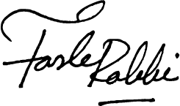





SL No. MHP/RMB/SOS03KW/STID324/2601/694 Date: 03 Feb 2026

This certificate extends the warranty of the 3KW Solar On-Grid System (Inverter Brand : Inhenergy . Inverter Model: SI-3K-T2 & 300W Solar Panel, RICH, PV Module, Model: DHP-72-300) for a period of 20 Years for Solar Panels & 3 Years for Inverter. This warranty covers the repairs or replacements of the damaged units at our discretion.
Lost, Natural disaster, Physical Damage, Installation of Panels under trees or in shaded areas will not carry the warranty provided by the company. This certificate is void if altered in any way.
Customer name : Rularl Market Building
Project Location : Mithamoin Bazar, Mithamoin Upazila, Kishoreganj.
Phone : +8801714075998

SREDA : StID#324
ABC Electrical Supervisor License No : S20210000492
ABC Electrical Contractor License No : C20240010376
Authorized Signature
Installation & Warrenty Certificate

